Guided Capstone Project Report

Big Mountain Resort has installed a new lift that increases the optionational costs by $1.5M this year. The resort wanted to plan for recouping that cost as well as optimizing the ticket pricing over the current average of competitor ticket prices plus a premium for the quality of resort Big Mountain operates. Jimmy Blackburn, the Director of Operations has brought this to the forefront and put in contact with Alesha Eisen the Database Manager to supply the data for analysis. With this we will be identifying the target ticket price based upon the new and existing lifts.

Alesha provided data for 330 completing resources along with the same data points for Big Mountain Resort. This data was then reviewed find any outliers and to identify the most predictive features of the resorts noted by the data. These features are the one that have the most influence on the ticket pricing value proposition: Vertical Drop, Fast Quads, Total Lifts, and Runs. After identifying the features to model it was found that a Random Forest Model would have the lower average error rate and as such was selected for modeling the ticket price.

To give a baseline for the current pricing in the market. As will all following dat the red line represents the current position of Big Mountain Resort within the data.

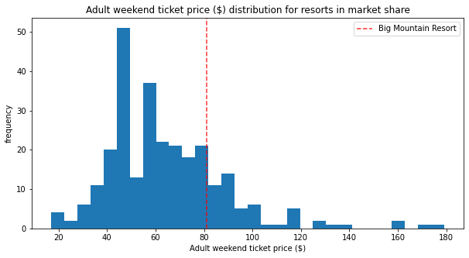

The key features are noted here.

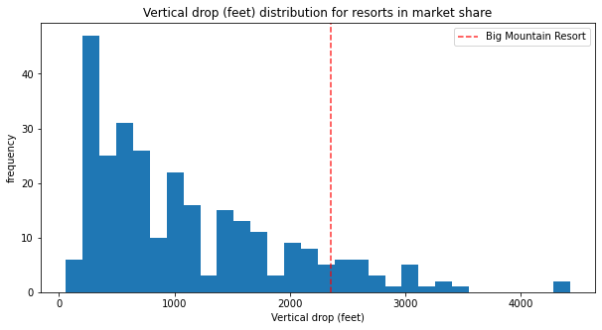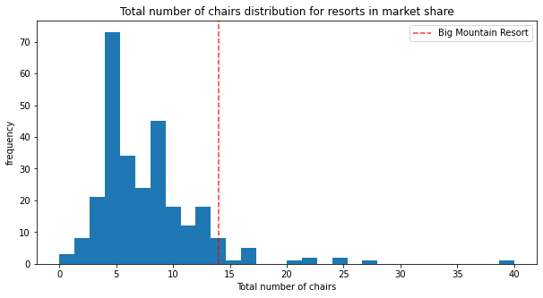

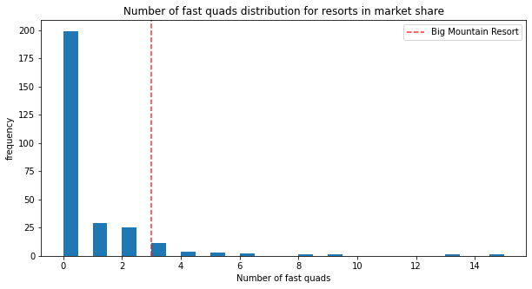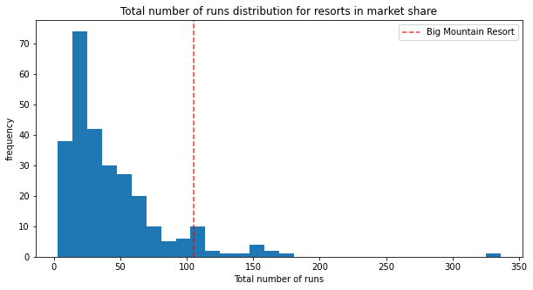

This information shows shows that Big Mountain Resort has room for a sustainable increasing the Adult ticket pricing over the current $81.00 price with an average absolute error range of $10.39.

This gives Big Mountain Resort a potential ticket price range of $85.48 to $106.26, while the current price is already the highest in the state. The lower of the values in that range $85.48 would increase revenue on the 350,000 seasonal visitors by $1,568,000 which will cover the operational costs of the new lift. Where as the noted median for the range $95.87 ticket price has the potential of increasing revenue for the same number of visitors by $5,204,500 for the season.

Secondary findings of this modeling show that closing as single run should have no adverse affects on ticket valuation. There is a relationship that demonstrates a downward trend in pricing for additional run closures and would require more analysis to identify the runs with the least impact. In the future the most positive impact on ticket pricing would be the described additional lift adding 150 ft of vertical drop to the lower part of the mountain without any additional snow making required, increasing the value proposition by $1.99. Increasing the length of the longest run has no measurable affect on pricing as Big Mountain Resort already has the longest run in its service area.